Experiment 37:
Aim:
37.Write a Pandas program to create a dataframe from a dictionary and display it.
Python code:
import pandas as pd

# Create dictionary
data = {
"name": ["Alberto Franco", "Gino Mcneill", "Ryan Parkes", "Eesha Hinton", "Gino Mcneill"],
"age": [18, 19, 20, 21, 18],
"country": ["Italy", "England", "Australia", "France", "England"]
}

# Create DataFrame from dictionary
df = pd.DataFrame(data)

print("DataFrame from the dictionary:")
print(df)
Output:
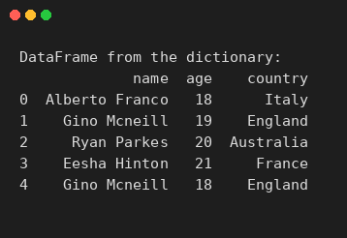
Experiment 38:
Aim:
38.Write a Pandas program to create and display a DataFrame from a specified dictionary data which has the index labels.
Python code:
import pandas as pd

# Create dictionary with data
exam_data = {
"name": ["Anastasia", "Dima", "Katherine", "James", "Emily", "Michael", "Matthew", "Laura", "Kevin", "Jonas"],
"score": [12.5, 9, 16.5, None, 9, 20, 14.5, None, 8, 19],
"attempts": [1, 3, 2, 3, 2, 3, 1, 1, 2, 1],
"qualify": ["yes", "no", "yes", "no", "no", "yes", "yes", "no", "no", "yes"]
}

# Index labels
labels = ["a", "b", "c", "d", "e", "f", "g", "h", "i", "j"]

# Create DataFrame with specified index labels
df = pd.DataFrame(exam_data, index=labels)

print("DataFrame with specified index labels:")
print(df)
Output:
